The Year in Business Dynamism

# Cited stats for datachecking

### Business formation statistics - national

1. Total applications in 2024: 448,758
2. Total high propensity applications in 2024: 157,678
3. % change in business application filing since 2023, excluding December 2023 for comparison purposes: -5.31%
4. Average monthly high propensity applications in 2024: 141,994
5. Total applications in January 2024: 447,715
6. Total applications in March 2024: 432,822
7. High propensity applications in July 2024 (low): 136,451
8. High propensity applications in November 2024: 157,678

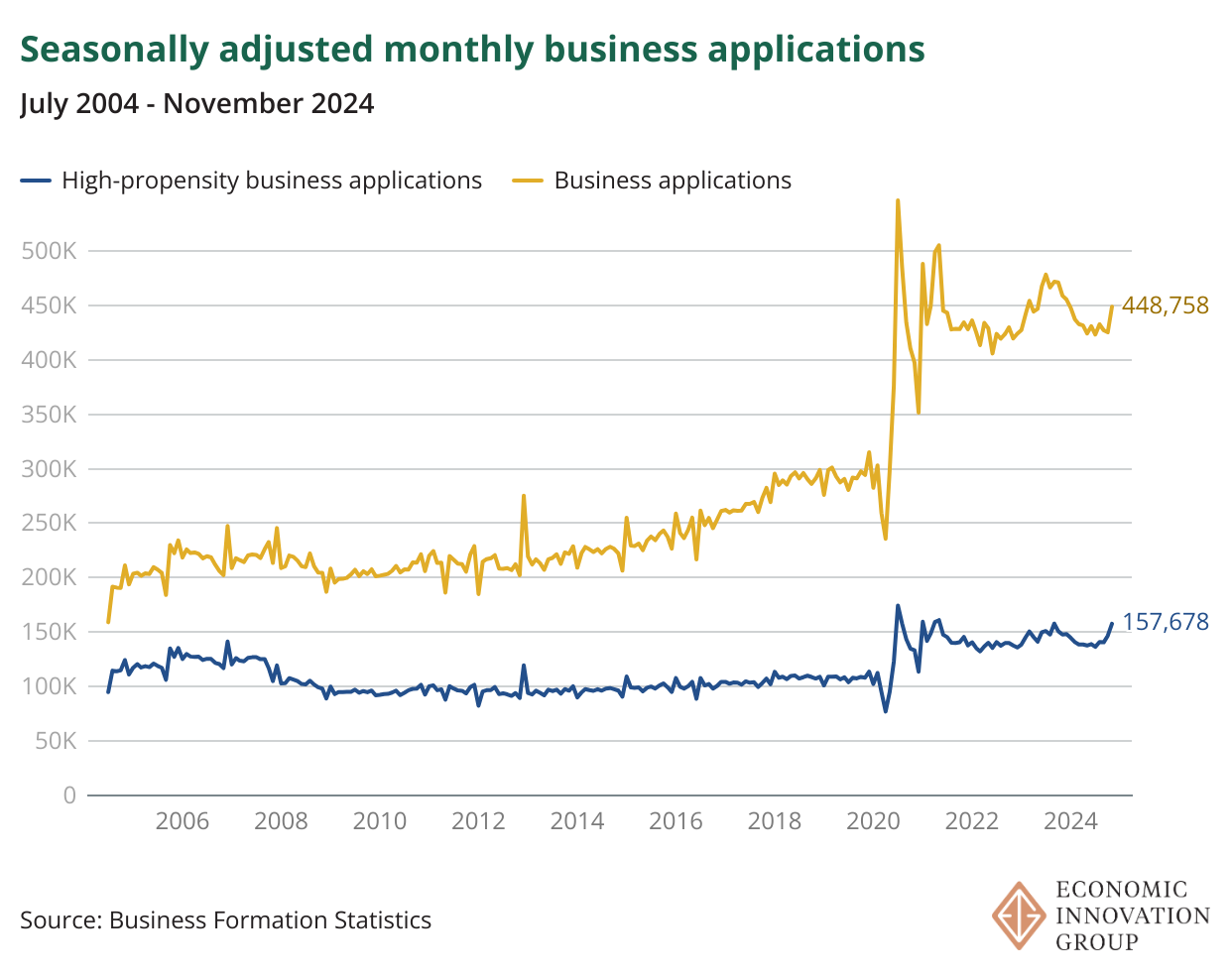

### Business formation statistics - industry

1. Applications in 2024 are higher than 2019 in 14/20 industries; excluding December 2019.
2. Mining fell 30.7% between 2019 – 2024; excluding December 2019.
3. Retail trade high propensity applications Nov 2024: 33,934
4. Retail trade as a % of all high propensity applications in 2024 (4th highest): 13.6%
5. highest industry as a % of high propensity applications in 2024: 16.6%; accommodation and food services
6. 2nd highest industry as a % of high propensity applications in 2024: 15.7%; construction
7. 3rd highest industry as a % of high propensity applications in 2024: 13.9%; healthcare & social assistance
8. Increase in healthcare & social service high propensity applications Nov 2022-Nov 2024: 16.3%
9. Increase in healthcare & social service high propensity applications Feb 2018-Feb 2020: 8.97%

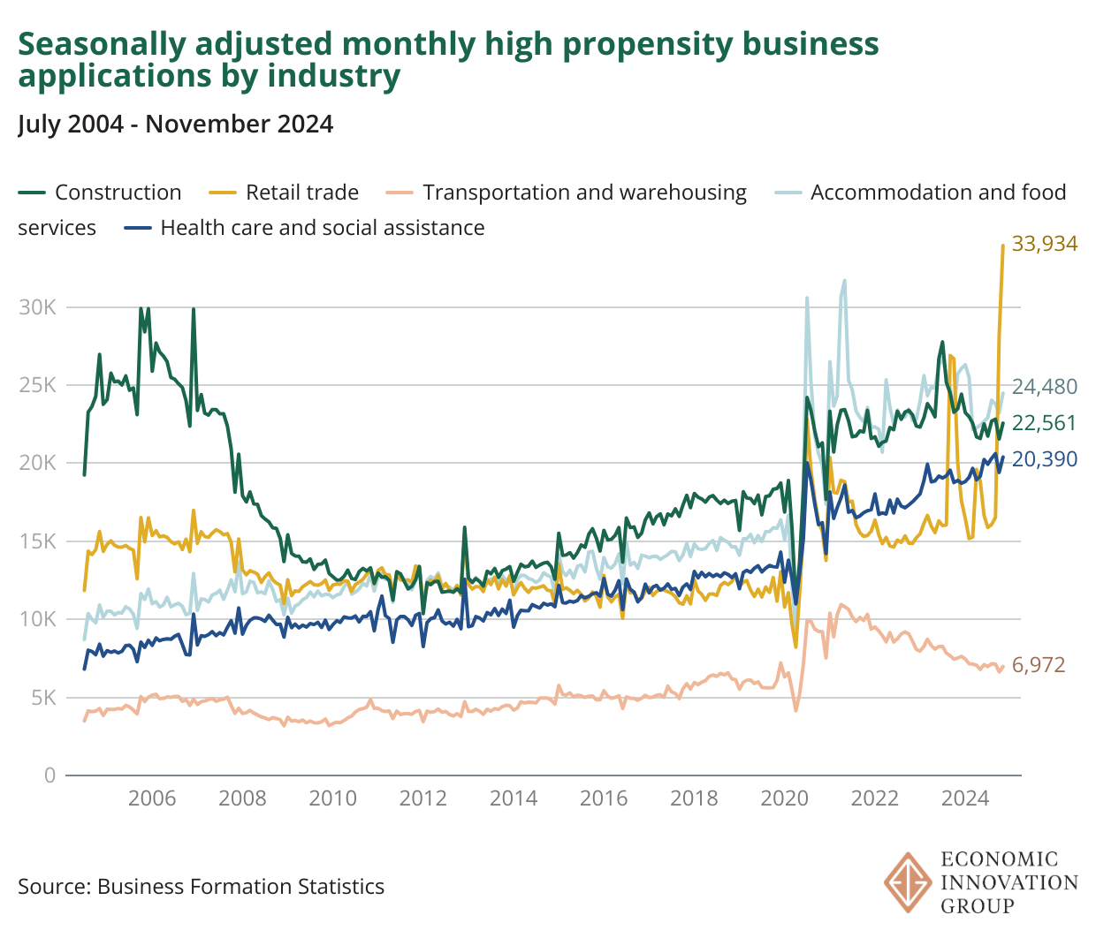

### Business formation statistics - state

1. Number of states that saw a decline in high propensity applications 2023-2024: 39
2. % of states that saw a decline in high propensity applications 2023-2024: 76.5%
3. State with the largest decline 2023-2024, & rate: Louisiana, with a decline of 15.9%
4. Top 3 states in terms of high propensity applications: California, Florida, Texas
5. Texas overtook New York for #3 spot in # of high propensity application filings in 2024 relative to 2023
6. Texas high propensity applications in 2019 (excl. December): 97,044
7. Texas high propensity applications in 2024: 136,824
8. West Virginia increase in high propensity business applications 2019-2024: 41.9%
9. States that more than doubled high propensity applications: 2
10. States that had > 50% increase in applications: 6

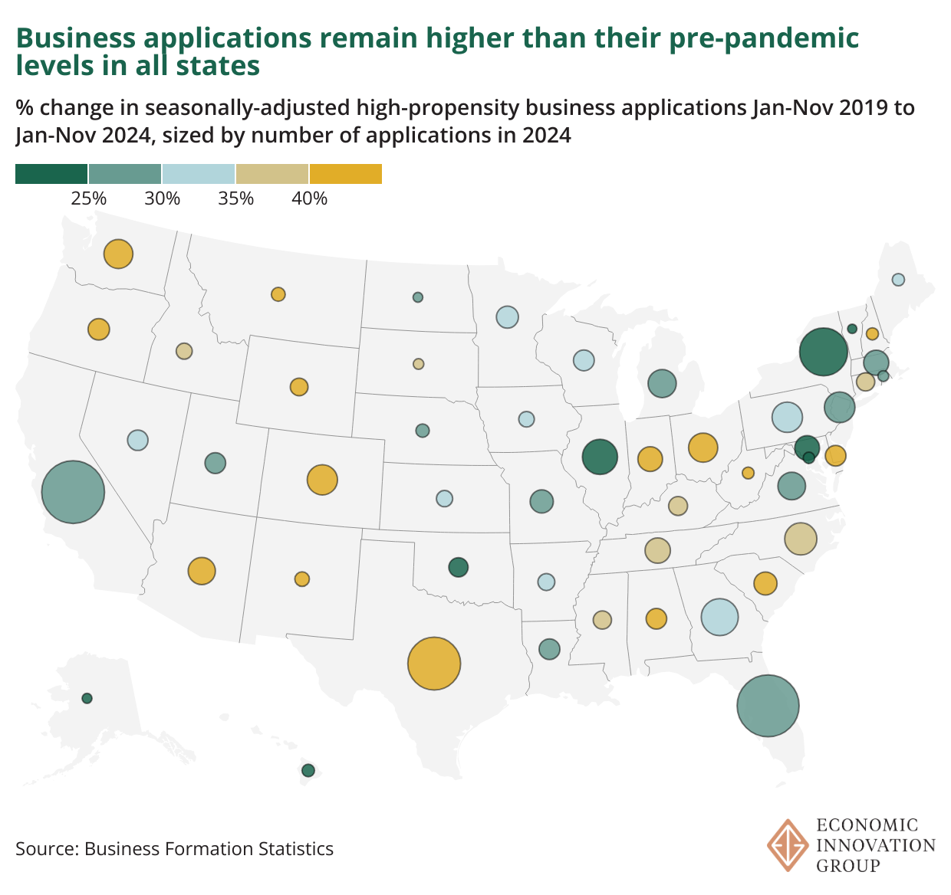

### Business and employment dynamics - national

1. Establishment births Q1 2024: 322,000
2. Pre-pandemic trend in establishment birth growth: 221,900
3. Births since Q3 2021: 4,434,000
4. Births between Q3 2017 and Q1 2020: 2,816,000

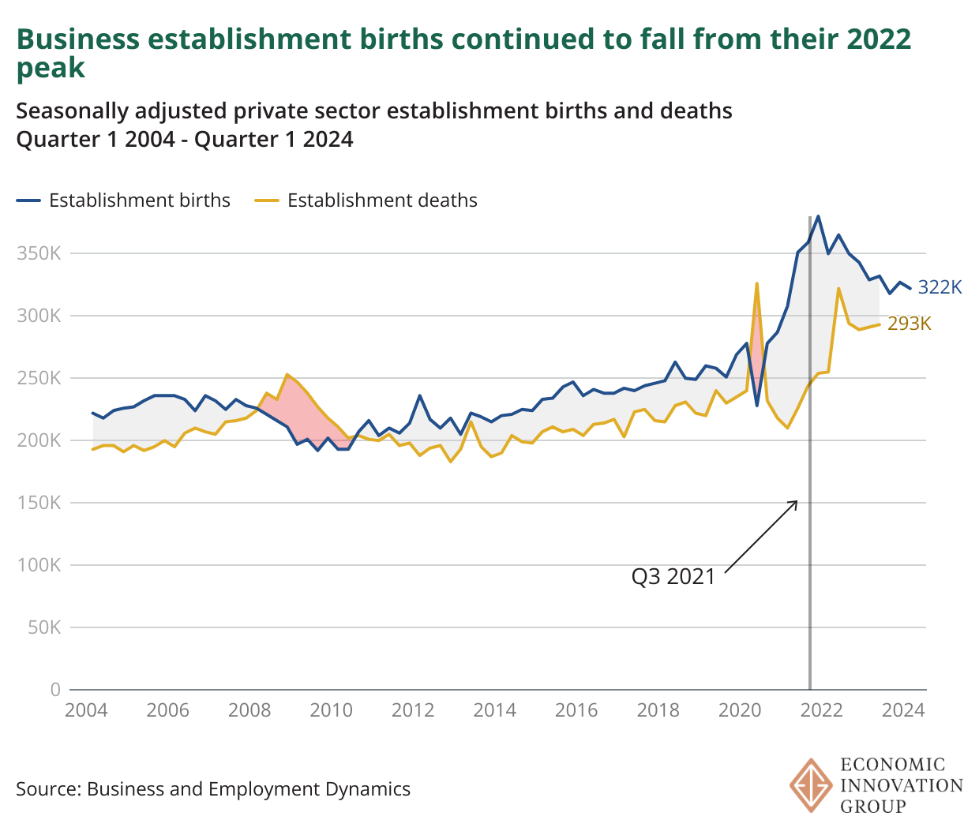

### Business and employment dynamics - state

1. States that had more establishment births in Q1 2024 versus Q1 2020: 41
2. Georgia’s increase in establishment births: Q1 2020 was 7,447, Q1 2024 was 34,988
3. Oregon’s drop: Q1 2020 was 9,744 , Q1 2024 was 4,973
4. Connecticut’s drop: Q1 2020 was 6,682, Q1 2024 was 3,662

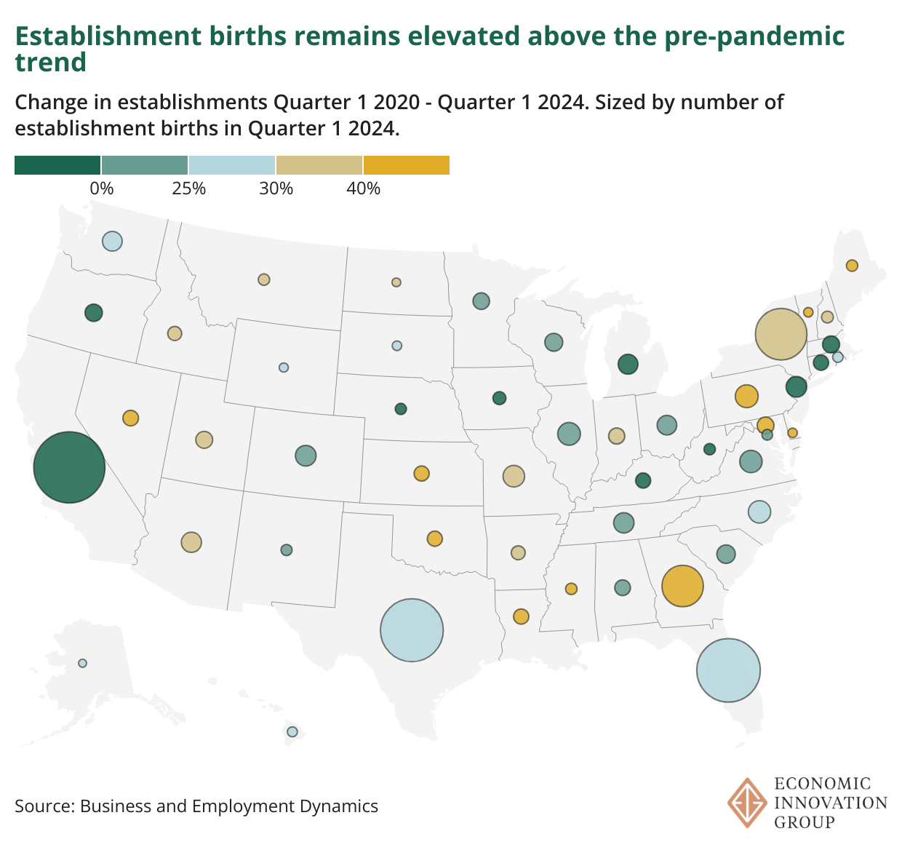

### Business trends and outlook survey - nation

1. % saying conditions were above average or excellent in last surveyed period: 33%
2. % saying conditions were above average or excellent in last surveyed period of november 2023: 31%

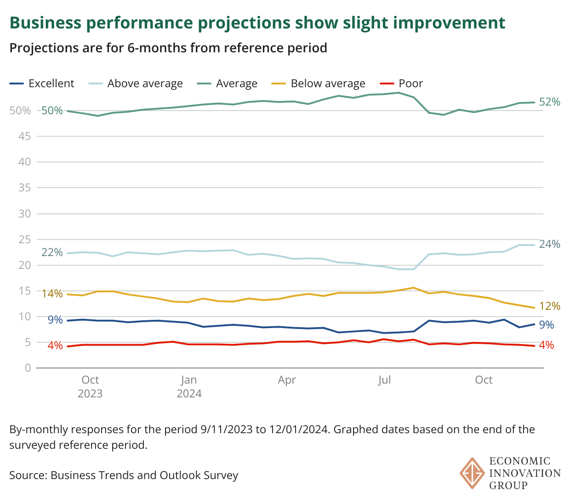

### Business trends and outlook survey - industry

1. Retail trade reporting average or excellent in last surveyed period: 23%
2. Healthcare and social services reporting average or excellent in last surveyed period: 21%
3. Accommodation and food services reporting average or excellent in last surveyed period: 40%

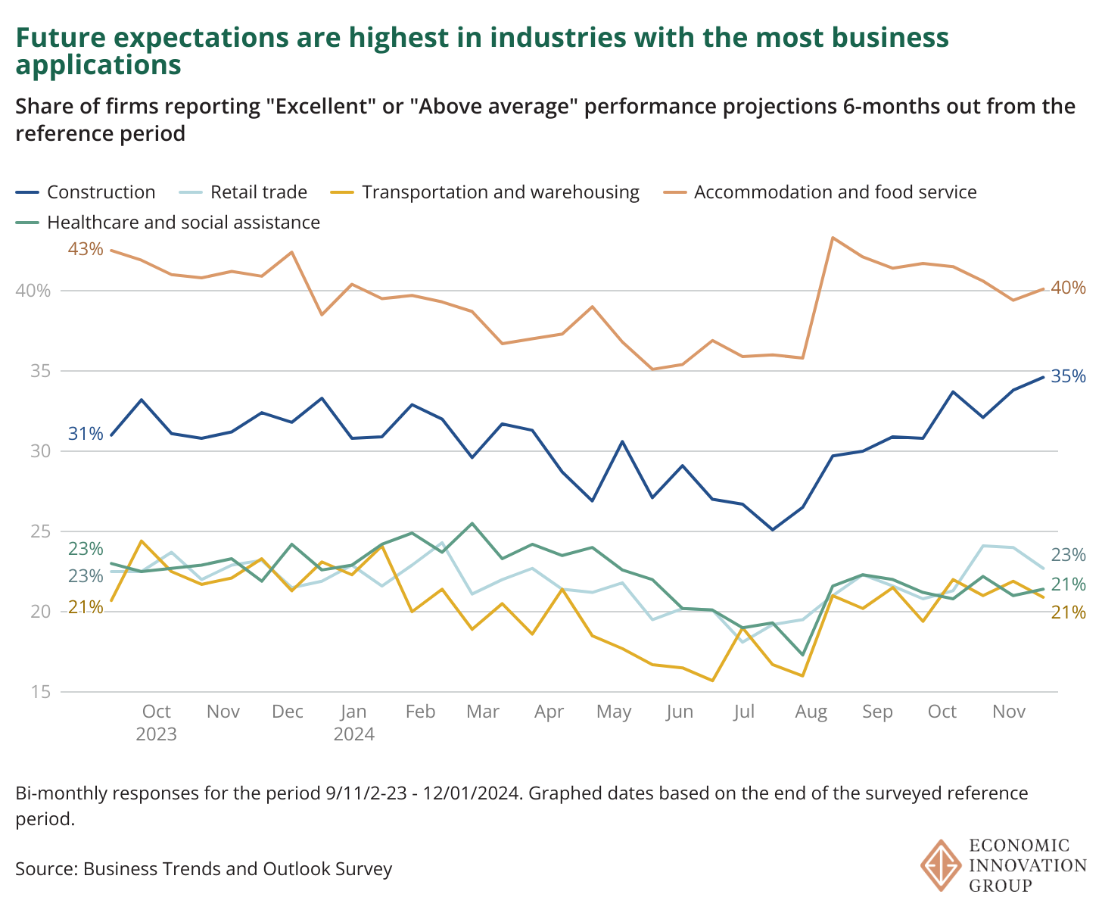

### Business trends and outlook survey - firm size

1. Businesses with fewer than 10 employees expecting conditions to be better than average or excellent compared to last surveyed period in 2023: 3%

